(Your Company Name Here) Enhancements

Scheduled for Friday, December 30th, 2022
Release Information for Lenders

Starting Friday morning, December 30th, 2022, an updated version of (Your Company Name Here) will be available for you. In our final system update for 2022, we are introducing a handful of quality-of-life improvements to ensure you have more features accessible at your fingertips. Among these features are new division level settings, Deferred Maintenance field on Commercial orders, and updated verbiage to the On Hold status notification. Please continue reading for a complete description of the latest enhancements we are introducing.

Bulletin Contents
- Hide Service Fees On Invoice | - Deferred Maintenance Field
- Updated On Hold Notifications Verbiage

Hide Service Fees on System Generated Invoices
(Your Company Name Here) has added a new division setting that will permit you to hide service fees from displaying on the system generated invoice. Disabling the service fees from view on the invoice removes that line item and adjusts the calculation accordingly. This application will assist in simplifying the payment process for those of you that utilize the system invoice as a placeholder for what the appraiser is due in remittance, especially when those fees are paid by the Originator.
How To Use This Feature:
Within your Administrator account, select Relationships, expand a division, and choose Edit Settings. Within the Billing/Services section, the Show On Invoice setting will automatically be enabled for your convenience.
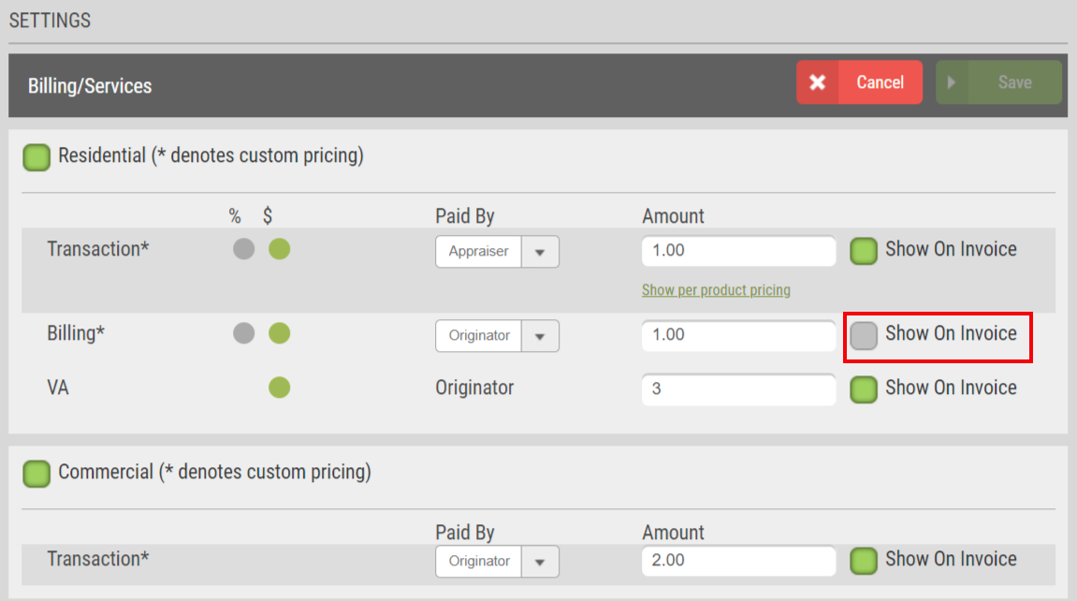
If you want the fees hidden from the system generated invoice, disable the box for the specified fee and SAVE. Please note this is a dynamic setting, meaning that any invoices viewed for orders placed within the division will no longer display the specified fee on the invoice for all users associated with the division. Additionally, this setting will only apply to Originator paid fees. Appraiser paid fees do not display on the system generated invoice for managed users.
Deferred Maintenance Field Added to Commercial Orders
We have added a new field to the Property Information tab for Commercial orders. The new field, Deferred Maintenance, will reflect Yes or No results, depending on the appraiser’s selection. Adding this field is another way (Your Company Name Here) ensures you have access to more visible fields without the necessity of combing through the entirety of the commercial appraisal report.
How To Use This Feature:
This field has been automatically added for your convenience. Open a Commercial order from your dashboard. Deferred Maintenance can be located towards the bottom of the Appraisal Report Details section on the Property Information tab. If the division has the Require Appraisal Fields from Appraiser enabled under the division’s Commercial settings, the Deferred Maintenance field will be a requirement during the appraiser’s report delivery process. Otherwise, Deferred Maintenance is an optional field.
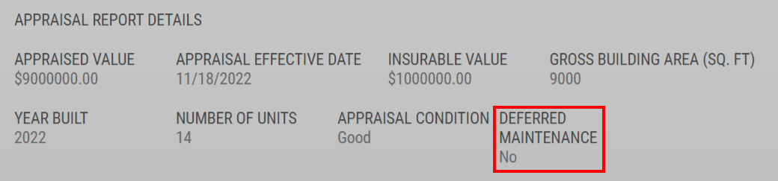
When Deferred Maintenance results are present, the Property Information tab will reflect Yes or No. Please note: this field will only have information present post-delivery IF the appraiser supplied an answer.
Verbiage Update to On Hold Notifications
We are updating the verbiage to the On Hold status to make it more apparent to appraisers to suspend work on the order until informed otherwise. This enhancement is intended to limit any confusion that may occur with the On Hold status for managed users and appraisers alike. The email notifications and Communications Log have been updated to reflect the new verbiage.
How To Use This Feature:
This verbiage change has been automatically added for your convenience. Access an order in a pre-delivery status from your dashboard. Select Hold Order on the right-hand side. This will place the order On Hold, notifying the appraiser and users on the order of the status change. The new copy in the email notification and Communications Log will reflect, “Order has been placed on hold. Please do not continue work on the appraisal without first confirming with the lender or receiving notice that the order has resumed.” Depending on your division settings, orders may automatically go to On Hold due to payment entry requirements, without the need for you to utilize the On Hold status manually. Once payment has been supplied, the order will resume automatically. Resuming the order manually will continue to function the same as it does today.

Please contact (Your Company Name Here) for any questions or concerns regarding this release.

