(Your Company Name Here) Enhancements

Scheduled for Friday, December 30th, 2022
Release Information for Appraisers

Starting Friday morning, December 30th, 2022, an updated version of (Your Company Name Here) will be available for you. In our final system update for 2022, we are introducing a handful of quality-of-life improvements to ensure you have more features accessible at your fingertips. Among these new features are updated verbiage to On Hold notifications, a simplified Cancellation Fee input process, and a new Deferred Maintenance field on Commercial orders. Please read below for a full description of each new enhancement coming out in this system update.

Bulletin Contents
- Updated On Hold Notification Verbiage  - Deferred Maintenance Field | - Automatic Direction to Cancellation Fee
Verbiage Update to On Hold Notifications
(Your Company Name Here) is updating the verbiage to the On Hold status to make it more apparent to you to suspend work on the order until informed otherwise. This enhancement is intended to limit any confusion that may occur with the On Hold status. Additionally, we have updated the email notifications and Communications Log to reflect the new verbiage not just for appraisers, but the lender as well.
How To Use This Feature:
This verbiage change has been automatically added for your convenience. When you receive an email notification stating that an order is On Hold, the new copy in the email notification and Communications Log will reflect, “Order has been placed on hold. Please do not continue work on the appraisal without first confirming with the lender or receiving notice that the order has resumed.” When the lender resumes the order, you will receive the Order Resumed notification just like you do today.
Simplified Cancellation Fee Process
Cancelled orders have a limited, 24-hour window for you to enter your trip and/or cancellation fee. If that window expires without a fee entered, the full amount of the order is refunded, and no amount is remitted to you UNLESS Customer Service gets involved. To simplify this process overall, whenever you receive a Cancellation notification, you will be automatically directed to the Billing Details tab where the Cancellation Fee feature is immediately accessible. This enhancement will reduce the number of clicks to get to the fee input page, where you can request a cancellation fee in the allotted timeframe, mitigating Customer Service involvement, and ensuring payment is remitted to you in a timely fashion.
How To Use This Feature:
This feature has been automatically applied for your convenience. When the Cancellation email notification is sent to you, select the HERE link in the body of the email. This will direct you immediately to the order’s Billing Details tab where you can input a Cancellation Fee without the need to login to your (Your Company Name Here) account.
Should you be working in your (Your Company Name Here) account directly through the site, once the cancelled order is opened, you will be directed to the Billing Details tab instead of the Communications Log, where you can proceed with entering a Cancellation Fee.
Deferred Maintenance Field Added to Commercial Orders
(Your Company Name Here) has added a new field to the Commercial report delivery screen. The new field, Deferred Maintenance, will reflect Yes or No results, depending on your selection. Adding this field to the Property Information tab is another way lenders can quickly verify the contents of your appraisal report, without back-and-forth communication.
How To Use This Feature:
This field has been automatically added for your convenience. Open a Commercial order from your dashboard. Deferred Maintenance can be found on the Deliver Report screen for all Commercial orders and can be located towards the bottom of the Appraisal Report Details section on the Property Information tab. If the commercial appraisal fields are marked with an asterisk (*), the Deferred Maintenance must be marked Yes or No during the report delivery process. Otherwise, Deferred Maintenance is an optional field.
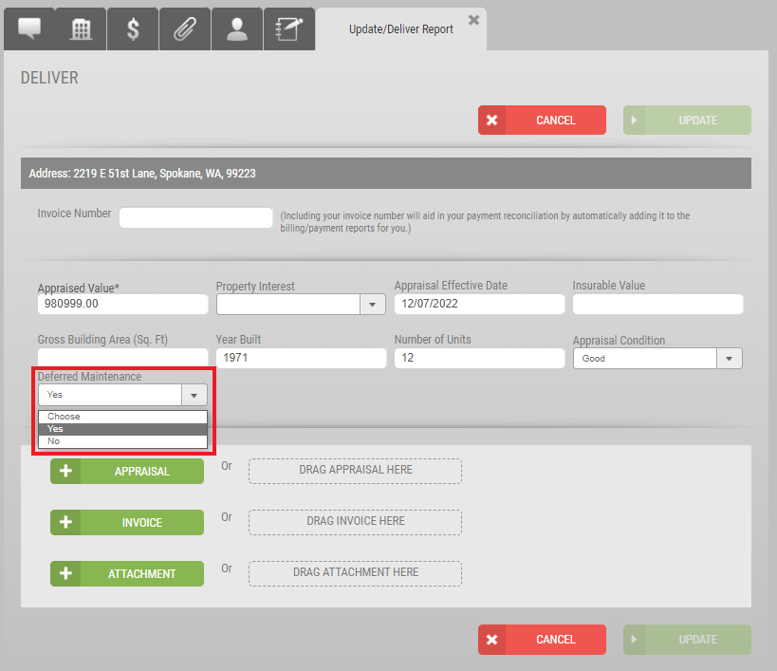
When Deferred Maintenance results are present, the Property Information tab will reflect Yes or No.

Please contact (Your Company Name Here) for any questions or concerns regarding this release.

