(Your Company Name Here) Enhancements

Scheduled for Friday, September 30th, 2022
  - Release Information for Administrators

Starting Friday morning, September 30th, 2022, a new version of (Your Company Name Here) will be available for you. We are releasing six new features: Create Tags for Appraisers, all VA Appraiser Notes Imported, updated VA New Order Form, Delay Timer for Auto Send Report to the Borrower, Search via City Name, and a Dashboard Results Update. Please continue reading for a thorough description of these new enhancements we are releasing.

Bulletin Contents
- Create Appraiser Tags  - Updated VA New Order Form  - Search Dashboard by City Name | - All VA Appraiser Notes Imported  - Send Report to Borrower Timer  - Dashboard Orders No Longer Capped
Create Tags for Appraisers and Appraiser Groups
(Your Company Name Here) is excited to introduce the ability for Administrators to create and apply tags to your list of appraisers and appraiser groups! With this enhancement, filtering your list of appraisers will allow you to categorize appraisers via tags, such as ‘Preferred,’ ‘On Probation,’ or ‘FHA Certified,’ instead of searching for appraisers by contact name, email, etc. Additionally, you can utilize these customizable tags when it comes to manual order assignments, ensuring the appropriate appraiser or group is assigned to the order to mitigate the period between order assignment and order acceptance. Please note: any applied tags to an appraiser’s profile will not change the automatic rotation assignment logic.
How To Use This Feature:
This feature is only accessible to Administrators with access to Relationships. Login to your (Your Company Name Here) account, select Relationships along the left-hand side of the screen, and choose the Lender Appraisers tab. At least one tag will need to be created and applied to an appraiser for the tag feature to populate results. Expand the appraiser or group you wish to create and apply a tag, via the arrow to the right. At the bottom of the profile, enter a tag in the New Tag Name field. Please note: the appraiser will never be notified a tag has been applied to their profile. This feature is only visible to you as the lender.
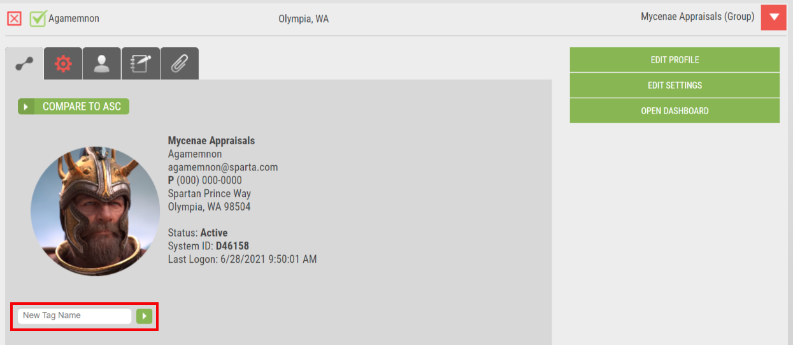
For a complete guide on how to create and apply tags, please refer to our Help Center article, Create and Apply Tags to Appraisers and Appraiser Groups. Once tags are in place, you can filter your Lender Appraiser list with the All Tags dropdown.
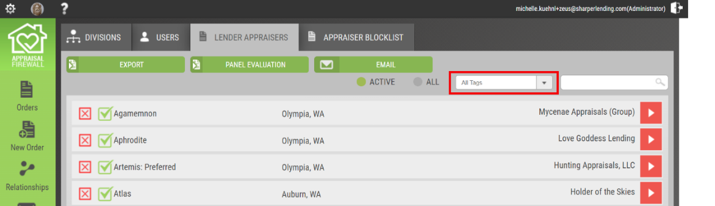
Any tags that have been applied will be listed. Selecting a tag will filter the list to show only appraisers that have the tag applied to their profile. You can apply multiple tags to a single appraiser. Tags administered will be appended to the appraiser’s contact name, so it will be easily visible when searching, whether that be on the Lender Appraisers tab, within Manage Appraisers, or the Assign Appraiser feature within an order.
All VA Appraiser Notes Retrieved
As (Your Company Name Here) continues to perfect the VA ordering process, we are delighted to share that any note the VA appraiser enters within the VA Portal will be eligible for retrieval! Prior to this release, only designated Appraiser Notes or SAR Notes were suitable to be imported to the Communications Log. Now, all Appraiser or SAR Notes regardless of Note Type can be retrieved directly into (Your Company Name Here). Applying this feature automatically will ensure all managed users have the full breadth of the order information in a single platform, omitting the necessity of working in multiple interfaces.
How To Use This Feature:
This feature has been automatically applied for all VA appraisal orders. When users select the Retrieve VA Updates feature, all VA appraiser notes will be imported into (Your Company Name Here) and accessible within the Communications Log.
Updated VA New Order Form
We have updated the VA new order form in (Your Company Name Here) to align with the latest fields the Department of Veteran Affairs (VA) has recently implemented on the VA Form 26-1805. By updating the new order form, users will be able to place VA appraisal orders successfully without data entry errors returning. Mitigating as many placement errors as possible ensures your orders post to the VA Portal quickly and conveniently.
How To Use This Feature:
This feature has been automatically applied for your convenience. Login to your (Your Company Name Here) account, select the New Order feature on the left-hand side of the screen. Ensure the loan type is VA for the appropriate fields to display. Updated fields now available are as follows: Number of Pages in Sales Contract, Buyer Agent and Seller Agent POC, Tidewater POC, APN/Lot Number, and Veteran/Surviving Spouse POC. The aforementioned fields will be designated with an asterisk (*), providing users with a roadmap of what fields are required.
Delay Timer for Auto-Send Report to Borrower
We are enhancing the way the Auto-Send Appraisal to Borrower feature works, by introducing a fully customizable delay timer at the division level. Through improving the current automation process, loan officers and processors will be able to examine the appraisal report before the borrower is automatically sent the document. This will ensure that LOs and processors are better prepared for any questions that may arise from the borrower(s) upon review. Additionally, utilizing the delay timer can assist with ensuring the report is accurate and complete before the borrower(s) receives a copy. Should any alterations be required from the appraiser, the delay timer will be rescinded until the appraiser has delivered a revised appraisal report. At which time, the delay timer will automatically trigger at the time of the newest delivery.
How To Use This Feature:
This feature is only accessible to Administrators with access to Relationships. Login to your Administrator account and choose Relationships along the left-hand side of the screen. From the list of Divisions, expand the division you want to enable the delayed report delivery timer via the arrow on the right, and select Edit Settings. Expand the General section, looking for the Completing Orders subcategory. Please note: the Automatically Send Appraisal to Borrower setting must be enabled for the new Delay Sending by _ Business Hours to be visible.
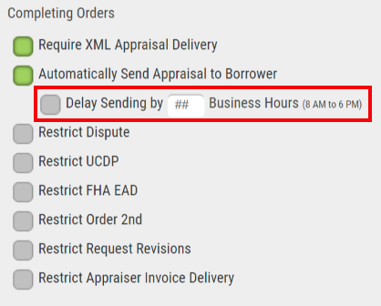
Once the number of business hours has been entered, be sure to select SAVE so your division updates are retained. After enabling this feature, all orders in a pre-delivery status will have the new delay setting timer in place. Current orders in a post-delivery status will have the delay timer applied when a new report is delivered. Additionally, the activity will be posted to the Communications Log for those managed users affiliated with the order. Below is an example of what the timer delay activity looks like in the Communications Log.
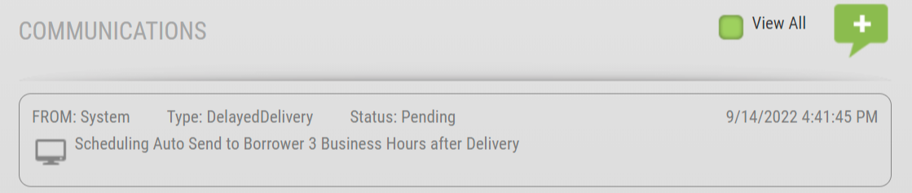
Search by City Name
We have updated the filter parameters when utilizing the search feature on the main dashboard to include the city name. Users can enter the city name of the subject property to narrow results when seeking a particular order. Providing additional criterion when searching for orders will allow users to discover and track orders easier.
How To Use This Feature:
Login to your (Your Company Name Here) account. From the main dashboard, enter a city name in the search field. If results match, a list of all orders matching the city name will be displayed. Entering the reference number, loan number, borrower surname, or street address of the subject property are still viable search methods.
Dashboard Orders No Longer Capped
We have optimized the way the dashboard loads orders, so you always have access to all your active orders. Previously, the dashboard was capped at loading the top 500 results. By removing the cap, users will always have the correct volume of data displayed between the widget panels and list view.
How To Use This Feature:
Login to your (Your Company Name Here) account. This feature has been automatically applied to the main dashboard so users can scroll through the entirety of the list of orders based on category, i.e., Post Delivery Orders, and see all the results, not just the top 500 results. The total number of results shown will match the total number of orders listed.

For questions or concerns regarding this release, please contact (Your Company Contact Information Here).

