(Your Company Name Here) Enhancements

Scheduled for Friday, May 27th, 2022
  - Release Information for Administrators

Starting Friday morning, May 27th, 2022, a new version of (Your Company Name Here) will be available for you. This release delivers our biggest release of 2022 to date! We are introducing enhanced VA retrieval features, block appraisers lender-wide, new Manual Review logic, set maximum per product pricing, and much more! Read on for the complete description of each new feature coming out this week.

Bulletin Contents
- Retrieve Updated 1805 and Appraisal | - Import COE Document
- Date Required Available to VA Orders | - Appraiser Blocklist
- Remove Appraiser Members  - Exclude FHA from Manual Review  - Added Fields to Completed Notifications  - Lender Specific Turn Time Report  - Require Bidding on Residential Orders  - Request Borrower Payment on Manager Bill Orders | - Value Determines Manual Review  - Set Maximum Per Product Fees  - Pro Forma Invoice  - Commercial Standard Bidding Terms  - Expanded Order Declined Notifications  - Trigger Payment Request Post-Acceptance

VA Appraisal Retrieval Enhancements
(Your Company Name Here) continues to refine the VA appraisal ordering process from beginning to end, with four new features being released in this system update. These enhancements focus primarily on the document retrieval process, ensuring users spend practically zero time navigating between the VA Portal and (Your Company Name Here) simultaneously. Among these features are new Retrieve Updated 1805 and Retrieve Updated Appraisal menu buttons, Certificate of Eligibility (COE) document imported as an accessible attachment, and the ability to add the Date Required on the property details page.
Retrieve Updated 1805 and Appraisal Report
We have added two new retrieval menu options in this release: Retrieve Updated 1805 and Retrieve Updated Appraisal. With the addition of these retrieval options, users can retrieve documents as needed, without the necessity of involving Customer Service, and permitting users to continue working in a single platform.
How To Use These Features:
Login to your account and access a VA order that already has an existing 1805 form. Please note that the Retrieve Updated 1805 menu option will only be accessible on VA orders that have an existing 1805 form.
To utilize the Retrieve Updated Appraisal feature, access a VA order that already has an existing report delivery. Please note that the Retrieve Updated Appraisal menu option will only be accessible on VA orders that have an existing report delivery.
Selecting either retrieval feature will prompt a confirmation overlay. Once the confirmation occurs, (Your Company Name Here) will show real-time updates as to logging into the VA portal and returning the most current 1805 or report delivery. If an updated version of either the 1805 form or an appraisal report is available, those documents will be posted to the Communications Log. Should the existing documents be the most current, a message will state that the 1805 or appraisal is up to date.
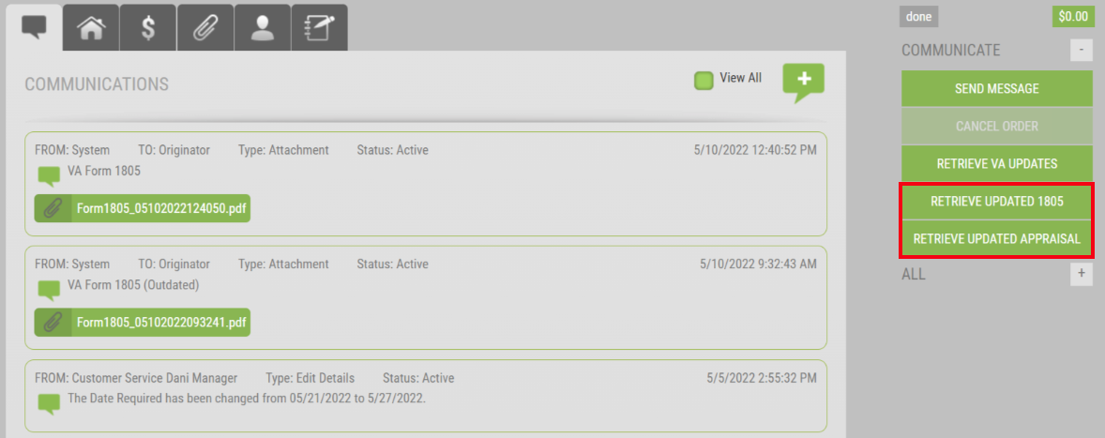
Certificate of Eligibility Imported from VA Portal
In our January 2022 release, (Your Company Name Here) introduced an enhancement that automatically pulled a Certificate of Eligibility (COE) on the Primary Obligor if we could verify one does not already exist or is no longer active. With this release, we are now importing the COE document itself! When a COE is present, (Your Company Name Here) will retrieve this document directly from the VA Portal, allowing users to view and access the document directly, instead of simply verifying a COE exists.
How To Use This Feature:
Upon VA order placement or by Retrieving VA Updates on an existing VA appraisal order, (Your Company Name Here) will reach out to the VA Portal automatically to verify if a COE is present. Through (Your Company Name Here) real-time VA messaging updates, users will be able to view when the COE is being downloaded directly into the platform. The COE will be posted and accessible within the Communications Log.
Date Required Now Available on VA Orders
As a way to assist in better tracking and managing all your appraisal loan types, (Your Company Name Here) has extended the Date Required field to VA orders! Now users can view the date required directly on their Orders dashboard and within the VA order’s property details tab, once supplied, to ensure their orders align with the expected due date. This new field is for your own personal tracking. Although the VA Portal does not supply the due date per order, you can utilize the VA’s expected turn-time schedule to input the Date Required within (Your Company Name Here) to properly track your orders coming due.
How To Use This Feature:
Access a VA appraisal order within (Your Company Name Here). Select the Property Information tab and choose Edit Details. Under the Property Information section, the Date Required field will be accessible between the Date Requested and Date Completed fields.
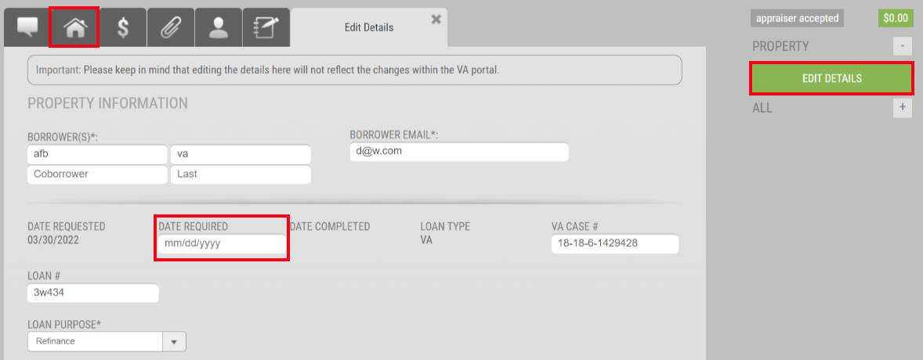
Utilize the calendar feature to select the appropriate date. Select SAVE at the bottom of the screen to update the details of the order. Once the Date Required has been input, VA orders will display said date on the Order dashboard when Date Required is enabled from the column chooser, as well as reflect appropriately within Custom Reporting.
Block Appraisers on All Your Divisions
We are excited to introduce the all-new Appraiser Blocklist feature, which will remove and block an appraiser/appraiser member across all your divisions. This feature also removes the appraiser from displaying on the All Appraisers list, whether you are viewing the panel or are working in an order. Through this enhancement, (Your Company Name Here) gives you an additional level of managing your appraisal panels, allowing you to adhere to investor do-not-use lists, internal exclusionary lists, watchlists, and more. You can even block multiple appraisers at a time, simply by adding the appraiser’s email address. All blocked appraisers are listed and tracked directly within the Appraiser Blocklist tab. Should you determine an appraiser can be re-admitted to your panels, you can remove the block, which will automatically restore all the pre-existing panel connections!
How To Use This Feature:
Login to your global Administrator account. Select Relationships and choose the Appraiser Blocklist tab along the top. To begin blocking specific appraisers from all your division panels, select the Add Appraiser button.
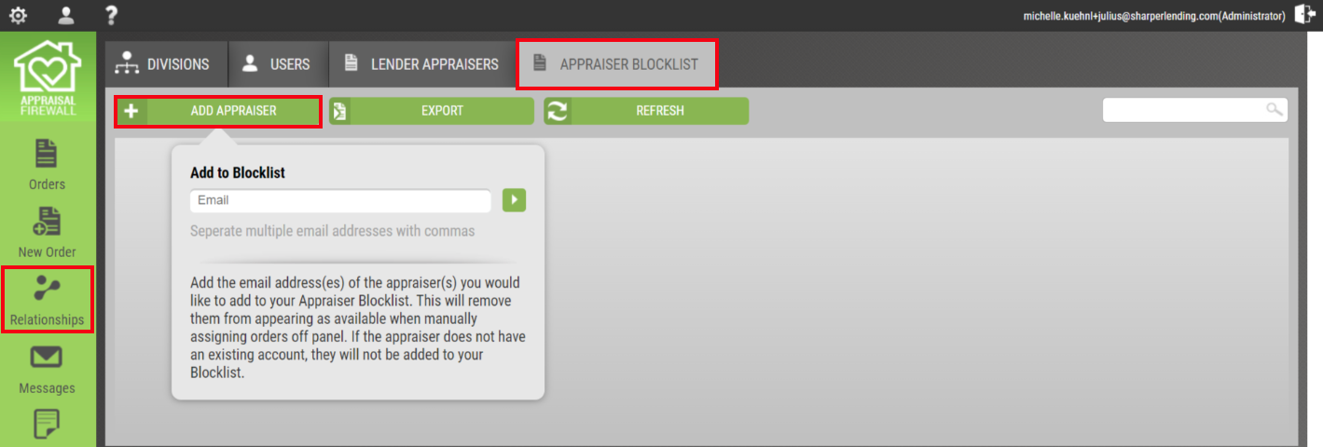
Enter the appraiser’s email address and select the arrow to remove the appraiser(s) from all divisions the appraiser is connected. Provide a comment to confirm removal and Approve. Upon approval, the listed appraiser(s) will display on the Blocklist.
Remove Appraiser Members Across All Divisions
We have enhanced the functionality of the Lender Appraisers tab so Administrators can remove appraisers and appraiser members across all divisions! With this new feature, remove any appraiser members directly from the Lender Appraisers tab, thus mitigating the time it takes to remove appraiser members individually throughout all your divisions. This action instantly disables the appraiser member across every division panel the appraiser group is active. Additionally, if you decide later to add the appraiser member back, you can do so via the Lender Appraisers tab, which will push the change to all divisions the appraiser group is connected.
How To Use This Feature:
Login to your Administrator account. Select Relationships and choose the Lender Appraisers tab along the top. Find a group, expand their profile, and select the Parties tab. Disable the box adjacent to the listed group member. Save Changes once complete.
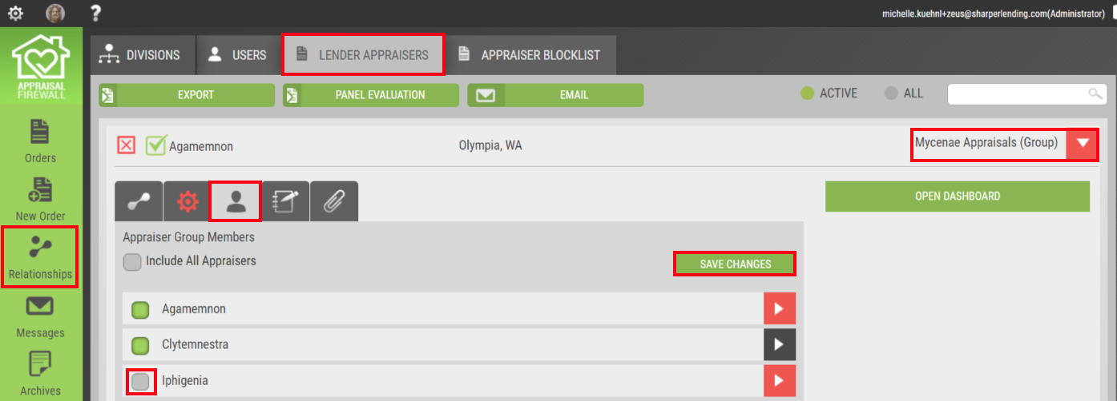
An overlay will appear requiring you to enter a comment to confirm removal of the appraiser member. Select Approve when complete. The appraiser member will be disabled from the parties tab on all divisions the group is connected, therefore preventing assignment from the appraiser group administrator, even if the member qualifies to perform the work. We have made adding an appraiser member back just as easy, following the steps described above, which will automatically add the member back to all divisions they were previously associated.
Appraised Value to Determine Manual Review
We have added a brand-new setting to the Manual Review process that considers the appraised value in determining whether the report warrants a review prior to being released to the borrower. This value-based setting examines the appraised value provided by the appraiser, in comparison to the Estimated Value or Sales Price entered on the order.
How To Use This Feature:
This setting must be enabled by the Manager that oversees your organization’s account. Once the Manager has enabled this feature, you will be able to verify the setting, Run Manual Review if Appraised Value is Less Than the Estimated Value/Sales Price, is in place by accessing your global Administrator account. From the lender level settings, expand the Manual Review Settings section. Since this new setting is lender-wide, all divisions that have Manual Review enabled qualify. Please note: this setting is contingent on the Estimated Value or Sales Price being input on the order.
Upon delivery, the system will automatically verify if the appraised value is below the Estimated Value or Sales Price, and if so, Manual Review is triggered, functioning exactly as it does today. Should the appraised value be at or above the Estimated Value or Sales Price, Manual Review is bypassed, even if the form type is enabled for Manual Review. As an aside, custom division settings will always take precedence over the lender level Manual Review Settings.
Exclude FHA from Manual Review
As a companion piece to the new value-based Manual Review setting, we have added the ability to omit FHA loan types from going through Manual Review. Now, you can customize if Conventional and/or FHA loan types should trigger the Manual Review process. Excluding loan types can be beneficial in reducing the number of reports your QC department must review, allowing you to close out appraisal orders quicker, and get the appraisal report in the hands of the borrower sooner.
How To Use This Feature:
To exclude FHA loan types from Manual Review, the Run Manual Review if FHA setting must be disabled by the Manager that oversees your organization’s account. You can verify the setting is enabled/disabled by accessing the lender level settings from a global Administrator account. Expand the Manual Review Settings section. Since this setting applies lender-wide, all divisions that have Manual Review enabled will remove FHA loan types from Manual Review consideration. Please note: Conventional loan types will always be eligible for Manual Review IF Manual Review is enabled on a division.
NOTE: If Run Manual Review if FHA and Run Manual Review if Appraised Value is Less Than the Estimated Value/Sales Price are both enabled, then the value will overrule the loan type. For example, if a 1004 form type returns an appraised value that is at or above the Sales Price or Estimated Value and the loan type is also FHA, then Manual Review is bypassed. For your convenience, we will automatically enable the Run Manual Review if FHA setting if you have Manual Review in place as FHA loan types are currently included in the Manual Review process. Please reach out to our Customer Service team if you would like to disable the FHA Manual Review setting.
Create a Maximum Per Product Pricing Fee
(Your Company Name Here) is excited to introduce an all-new maximum fee setting structure for per product pricing. This feature grants lenders more latitude when disclosing the appraisal fee to your borrowers, even before the appraiser accepts the order! As an additional bonus, this maximum fee setting structure works in conjunction with conditional acceptance. Now, when an appraiser accepts your order under the maximum fee amount, the system will automatically approve the order, no longer requiring you to Approve or Decline the conditions. Through this automation, your orders can move through the process without delay!
How To Use This Feature:
From Relationships, select a division you want to create maximum fees on your products, and choose Edit Settings. Expand Pricing and if you have Coverage Areas listed, expand a Coverage Area. Adjacent to the fee field, we have included a drop-down menu where you can designate if you want the fee entered as ‘Fixed’ or ‘Maximum.’ Select Maximum, enter the maximum fee for the product type, and SAVE to retain your changes.
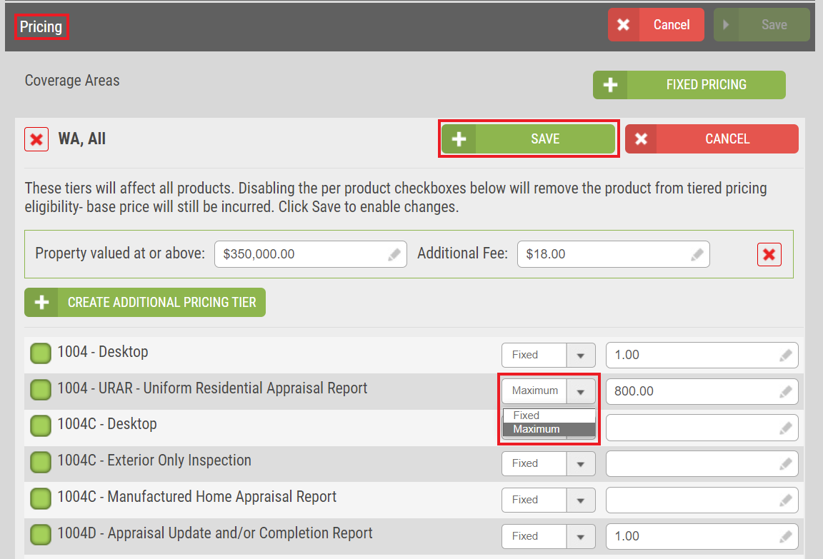
Now, when the appraiser accepts the order, if the fee the appraiser inputs is under the maximum fee threshold, the order will automatically bypass the negotiating status (if you have Conditional Acceptance enabled), and update to Appraiser Accepted.
Added Appraiser Turn Time Analytics
We have modified the All Appraisers Average Turn Time report to now parse out the average turn time for your panel of appraisers! Previously this report generated results for all appraisers system wide over the last year. Now, you can run the average turn time report on just your panel of appraisers. Additionally, you can run the report for a specified date range. This will allow you to analyze how quickly your panel of appraisers return their reports for your entire organization, or you can even compare how your panel of appraisers stack up versus the system as a whole. The addition of these analytics can assist in providing tangible results to alter your panel, adjusting the date required on certain form types, etc. More data is at your fingertips!
How To Use This Feature:
Login to your Administrator account and select Reporting. Expand the All Appraisers Average Turn Time report. Select the party of appraisers you want to generate a report: All Appraisers (all appraisers in the system) or My Appraisers (your panel of appraisers across all divisions).
Utilize the date range to customize the length of time you want results to be returned. You can filter by State or County, include appraiser information, and setup the report to run automatically. Once you have filled out the appropriate fields, select Run Report.
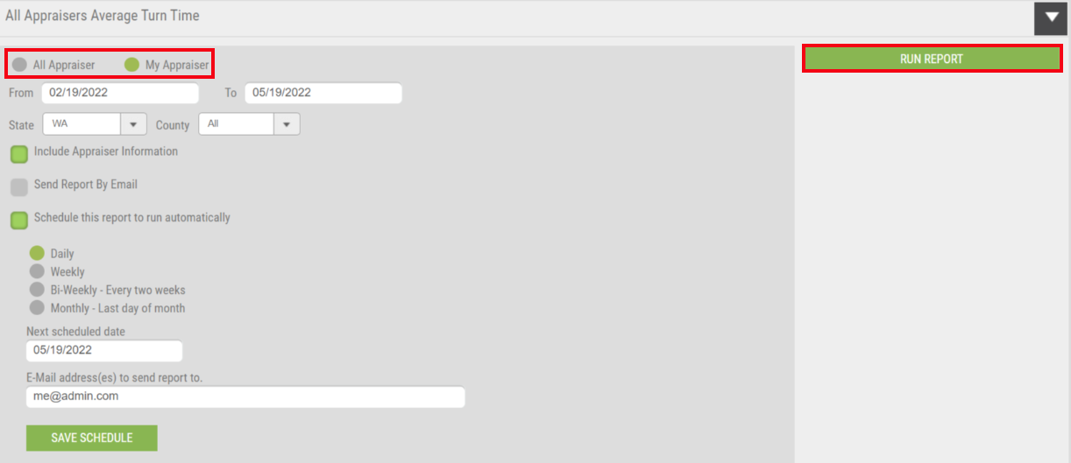
New Pro Forma Invoice
We are introducing a Pro Forma invoice so your team will know in advance an invoice is pending and subject to change. Additionally, this will provide an upfront glimpse into the expected cost of the appraisal and any related payment details. The Invoice feature will now be available after the order has been accepted. All other functionality of the system generate invoice remains unchanged.
How To Use This Feature:
Login to your account and open any order in a post-acceptance status. From the Billing Details screen, select Invoice. The print version of the invoice will show a Pro Forma watermark. Once a delivery has occurred, the Pro Forma watermark will be removed. The invoice will continue to be available on the Billing Details and Documents tabs.
Notify Order Originators on Appraiser Declines
We are broadening the scope of which users qualify for the Notify if Appraiser Declines Order division setting to include Administrators AND order originators. This email notification will ensure all users associated with the appraisal order are appropriately updated. Expanding the user types will assist in trimming down the status request inquiries internally.
How To Use This Feature:
This enhancement only applies to divisions that have Notify if Appraiser Decline Order enabled. You do not need to take any additional action if this setting is enabled as (Your Company Name Here) will send out email notifications to all users on the order.
New Fields Added to Report Completed Notifications
We have added three new fields on the Report Completed email notifications to provide users with more order information without needing to access (Your Company Name Here) directly. These new fields are: Estimated Value/Sales Price, Appraised Value, and Appraisal Condition. For your convenience, we have automatically added these fields to the email notifications.
How To Use This Feature:
The Report Completed email notification will automatically have the three new fields displayed within the notification. (Your Company Name Here) will pull the Appraised Value and Appraisal Condition directly from the report delivery and include those values within the email notification. Please note: the Estimated Value/Sales Price must be entered on the order to be displayed within the email notification, otherwise this field will be hidden.
Require Bidding on Residential Orders
In this release, we are including a new division setting where the bidding process will be a requirement on any Residential appraisal order. When the Require Bidding setting is applied, (Your Company Name Here) automatically enables the Request Bid feature on the New Order screen, ensuring that the order is placed for your appraisers to bid on. Additionally, we have safeguarded the Request Bid feature to be a non-editable field on new order creation for Supervisors and Originators. This will provide greater control over order placement accuracy.
How To Use This Feature:
From Relationships, expand the division you want to enable the setting, and select Edit Settings. Require Bidding can be found within the Placing Orders section in General settings. To enable Require Bidding, you must have Allow Bid Requests enabled.
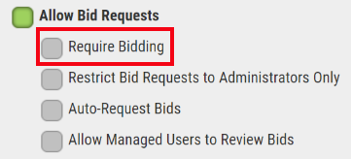
Once the Require Bidding setting has been enabled, the Request Bid feature on the new order screen will automatically be enabled. Place the order as normal and send out your bid requests to your appraisers.

Upload Standard Bidding Terms to Commercial Orders
Commercial orders require unique care, which is why (Your Company Name Here) has added the option to upload a Standard Bidding Terms letter at the division level to be sent on every placed Commercial order automatically. Appraisers that receive bid requests on Commercial properties will be able to access and view your organization’s terms and expectations, prior to supplying any bid. This will provide an added layer of transparency for appraisers as what is expected during bidding process.
How To Use This Feature:
From Relationships, select the division you want to enable this option, choose Edit Settings, and expand Commercial. Enable the box adjacent to Use Standard Bidding Terms and upload your attachment. Be sure to SAVE to ensure your changes are retained.
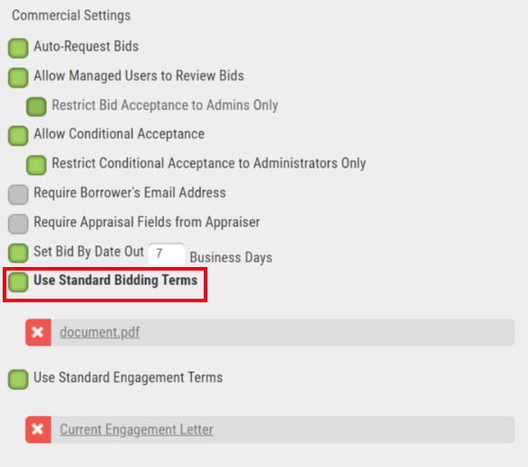
On subsequent Commercial order placements, your Standard Bidding Terms document will automatically be included as an accessible document for the appraiser to review via the Communications Log and Documents tab.

Enhancements for Lenders Set to Manager Bill
In this system release, we have updated two Request Credit Card from Borrower features, both of which can be triggered after the appraisal order has been placed, but only if your division is setup as Manager Bill.
Request Borrower’s Credit Card When Switching Payment
Orders initially placed as Manager Bill have a Change to Credit Card feature, found within the Billing Details screen. We have added a Request from Borrower setting that will allow users to send a payment required email to the borrower as opposed to needing the borrower’s credit card information on hand. This setting provides more autonomy to users updating and managing their orders and grants the borrower more control of how their credit card information is accessed.
How To Use This Feature:
This setting is only available on Manager Bill orders. From the Billing Details screen, select Change to Credit Card. There is a radio button under the Card Update section you can enable to Request from Borrower.
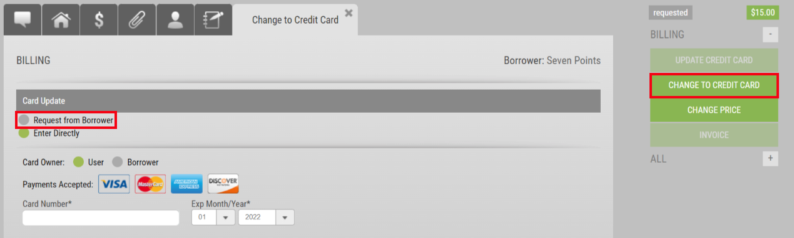
Fill out all the required fields and select Update Card at the bottom of the screen. The borrower will receive a payment required email notification where they can submit payment directly through the system.
Trigger Borrower Payment After Order Acceptance
(Your Company Name Here) is offering the ability to trigger borrower payment AFTER the appraiser has accepted the order. This will aid in avoiding incorrect appraisal fee disclosure to the borrower. Previously payment had to be requested prior to order acceptance. Altering the payment collection workflow benefits borrowers and lenders alike, while ensuring the appraiser can still collect payment for work completed.
How To Use This Feature:
Once the setting has been enabled, the borrower email will become a required field (if you do not already have that setting enabled) on the New Order form. Users will need to select Credit Card – Request from Borrower as the payment method in the Order section. Complete the order as usual. Routing to an eligible appraiser will continue to function normally. When an appraiser accepts the new order request, (Your Company Name Here) will automatically trigger the payment request to the borrower, noting all activity in the Communications Log. Once the borrower supplies payment, the order will continue along its trajectory. Please note: orders utilizing this process that are in ‘payment review’ (i.e. waiting for the borrower to submit their credit card payment), will prevent the appraiser from delivering the report UNTIL payment has been made. After payment has been received, the appraiser will be able to deliver normally.

Please contact (Your Company Name and Contact Information Here) for any questions or concerns regarding this system update.

