(Your Company Name Here) Release Scheduled for
Friday Morning, March 4th, 2022
Release Information for Lenders

Starting Friday morning, March 4th, 2022, a new version of (Your Company Name Here) will be available to you. Within this release, we have enhanced the usages for Verisite, added a new pricing prompt when editing an order’s details, Completeness Check results return on all report deliveries, and more!

Bulletin Contents
- All-New Verisite Templates  - VA Issue Shown in Subject Line  - Edit Details Prompts Price Adjust  - Expanded Search Criteria on Lender Appraisers Tab | - Verisite for Businesses  - Successful Completeness Checks  - Turn Times Translated to Dates  - Updated On Hold Orders Process

Save Time with Customized Verisite Templates
Placing Verisite orders within (Your Company Name Here) just became much more simplified! Now, you can create an array of Verisite templates to suit your organization’s order placement needs, including specific new construction progress requirements, equity lending situations, residential addendums you may need, and more. Create and customize any number of Verisite templates to get orders placed faster than ever. These templates will be accessible directly on the New Order screen, saving your users time from individually adding separate photo categories, photo requirements, and more during order placement.
How To Use This Feature:
Access the lender level settings from your (Your Company Name Here) global Administrator account. Expand the Verisite Settings section. Please note that Verisite Settings will only be displayed if at least one Verisite product has been enabled for your organization.
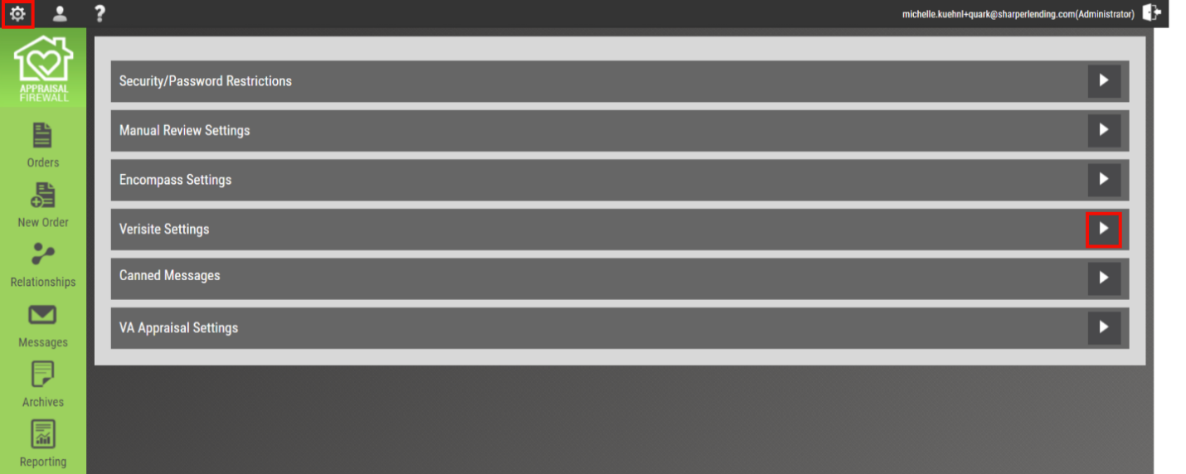
Select Create Template to begin building your first Verisite template. Important: If you had an existing Verisite format, we have automatically copied those instructions as a ‘Main’ template for your convenience. You can edit the name of your template at any time.
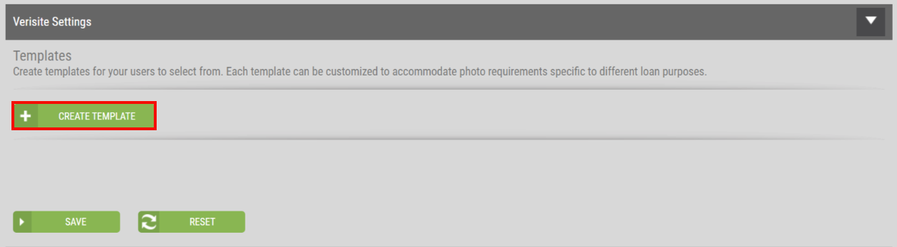
Enter a Template Name and select Add to continue to customize the template, and once they are in place, those templates will be available to select on the New Order screen. For complete detail and a full walkthrough of the Verisite Template creation process, refer to the Verisite Guide for Lenders article in the Help Center.

Verisite is for Businesses Too
You can place Verisite orders for businesses with our new Borrower Is a Company feature! We have enhanced the Verisite New Order screen to handle entering a Company Name when Borrower Is a Company has been selected. You no longer need to split a business name between the First Name field and the Last Name field. Additionally, the Verisite order creation process remains the same.
How To Use This Feature:
Create a new Verisite order. Within the Loan section on the New Order screen, enable Borrower Is a Company. This will replace the Borrower(s) First Name and Last Name fields with a Company Name field.
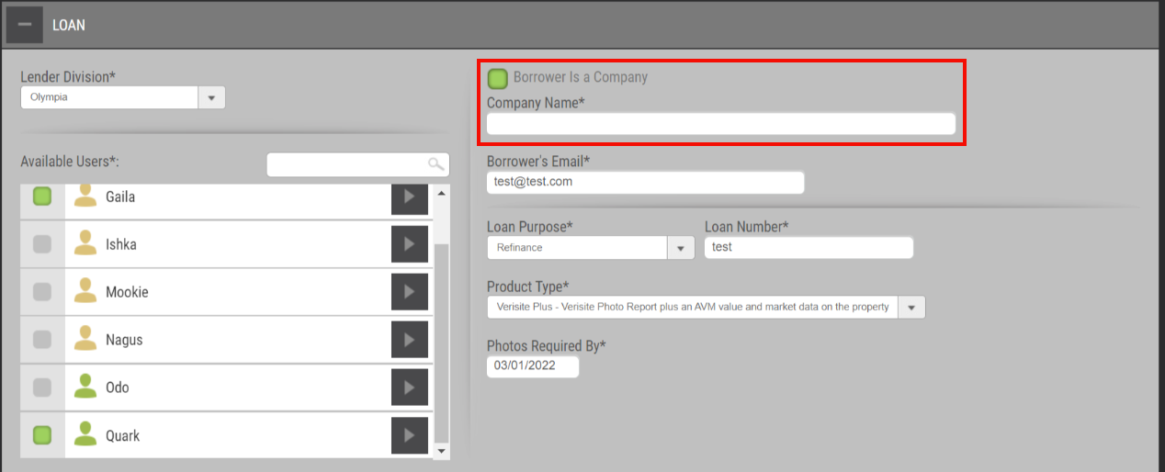
Proceed with filling out the order as normal. Upon placement, you will see the company name displayed in the borrower field.

VA Email Notifications Show When Action is Required
The (Your Company Name Here)-VA order solution continues to evolve, and our newest enhancement for VA orders now includes an updated subject line! To separate the numerous system generated emails users receive in a day, we have included VA Issue in the subject line for VA order email notifications.
How To Use This Feature:
The email notification only applies to those VA orders that encounter an issue. An example of an issue returned by the VA Portal, resulting in an email notification, would be "COE not valid on the borrower.” Should an issue occur on the VA order, the subject line of the email notification will state VA Issue while retaining the property address and borrower name within the subject line.

Completeness Check Available on Successful Results
We have updated the Completeness Check option to generate on Successful appraisal report deliveries, adding an additional level of validation to your review process. Now, Completeness Check results will return on every single report delivery, whether issues are found within the appraisal report or not. This will provide proof of a successful review or quality control process being performed on appraisals for investor or internal lending requirements. Within the contents of the Successful Completeness Check output, you will find a statement that no issues were found in accordance with standard underwriting rules and USPAP requirements. As a special note for Encompass users, we have created a new setting you can enable for the Completeness Check results to be returned to the eFolder upon retrieval. More information related to enabling this setting for Encompass can be found below.
How To Use This Feature:
You must have the Completeness Check feature enabled on your division(s) to have the Successful and Unsuccessful results available. When an appraiser delivers their report, the Completeness Check will return a PDF output verifying that the Completeness Check found some issues or zero issues within the appraisal report. All Completeness Check results will continue to be available on the Communications Log and the More Documents section within the Documents tab.

Special Note for Encompass Users:
To enable the Completeness Check as a returned form to your eFolder, login to your (Your Company Name Here) global Administrator user account. Select the lender level settings and expand Encompass Settings.
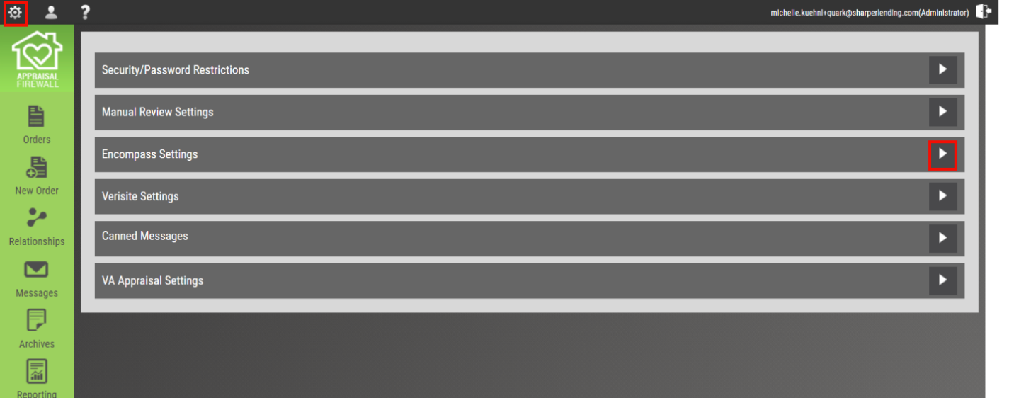
Under the Returned Documents section, enable the box adjacent to Completeness check results and SAVE at the bottom.
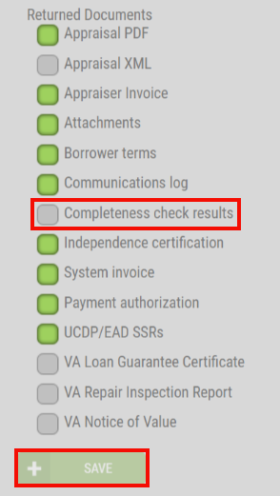
Upon retrieval into Encompass, the Successful or Unsuccessful Completeness Check result will be returned to the eFolder for the specified loan file.

Editing Details Prompts Users to Update the Price
To ensure Residential appraisal orders have the most accurate pricing available, we have added a new prompt whenever a user updates the following order details: Appraisal Type, Property Is, and/or Loan Type. This new overlay will engage the user to update the pricing on the spot if a price change is warranted. For your convenience, should pricing need to be updated, we will automatically direct the user to the Billing Details screen to adjust the order fee. Please note, if the user has been restricted to not have access to the Change Price feature, (Your Company Name Here) honors that restriction, and this prompt will not occur.
How To Use This Feature:
Go to the Property Information tab within an order and select the Edit Details button. Adjust the Appraisal Type, Property Is, and/or Loan Type fields, and SAVE at the bottom of the screen. Once the SAVE action is committed, an overlay will be presented to the user asking if a price change is needed.
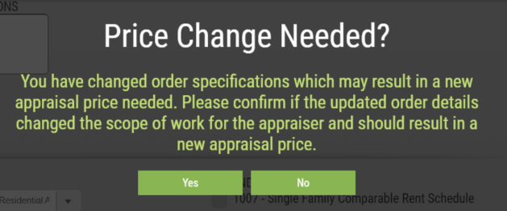
Selecting Yes will save the edits made to the order and direct the user to the Billing Details screen, where they can immediately enter the price change. If a price change is not necessary, the user can select No, which will save the edits made to the order, and direct the user back to the Communications Log.

Bidding Turn Times Automatically Translated into Calendar Dates
Turn times on any Residential or Commercial bidding orders are now automatically translated to the correlating calendar date, saving users time from computing the turn time in days in the moment. The corresponding calendar date now matches the Date Required column customizer, preventing the necessity from switching between the order details and the main dashboard.
How To Use This Feature:
Access a Residential Bidding or Commercial order. Open the Property Information tab and look for the Turn Time section on a Commercial order, or the Bid Turn Time section on a Residential Bidding order. You will see the turn time in days, with the corresponding date adjacent to the number of days. Below is an example of what the date translation looks like on a Residential Bidding order.
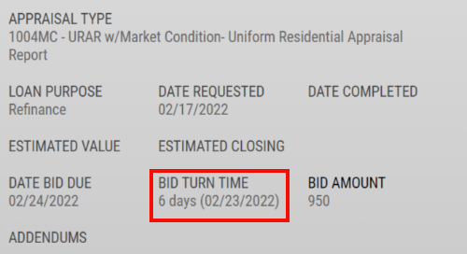
We have also added the turn time date translation to the Print version of the order form. Please note: the date translated from the turn time in days in only available after an appraiser has successfully accepted the order.

Search Criteria Expanded Within the Lender Appraisers Tab
We have expanded the search parameters within the Lender Appraisers tab to return results on an appraiser’s name, email address, and now the appraisal company name! Enter a few keystrokes in the Search bar and the system will return any applicable results.
How To Use This Feature:
Login to your Administrator account, select Relationships, and click the Lender Appraisers along the top. In the Search bar on the right-hand side, enter any portion of the appraisal company name, appraiser’s name, or the appraiser’s email address. Results will be returned immediately.

Pre-Accepted, On Hold Orders Now Disable Auto-Reassignments
Orders that have been placed On Hold and have yet to be accepted by an appraiser, will now automatically disable the auto-reassignment process to prevent the order from continuing through the panel rotation. We have added this additional level of rotation logic to curtail issues arising from appraisers accepting and performing work on an idle order. Any orders placed On Hold post-acceptance will continue to function exactly how they do currently.
How To Use This Feature:
This feature will automatically occur on orders that are in an assigned status and placed On Hold. Once the Hold Order action has been committed, the currently assigned appraiser will receive the order reassigned email notification. Any users associated with the order will also receive the On Hold email notification. Additionally, we have disabled the Assign button within the Parties tab while the order remains On Hold. Once the order has resumed, you will be able to assign the order to the appropriate appraiser.
Contact (Your Company Name Here) for any questions or concerns.

