(Your Company Name Here) Release Scheduled for
Friday Morning, March 4th, 2022
Release Information for Appraisers

Starting Friday morning, March 4th, 2022, a new version of (Your Company Name Here) will be available to you. Within this release, we have made a slight adjustment to the Deliver Report screen, making the Deliver button easier to locate and use. Read the full enhancement description below.

Deliver Report Button Added to Top of the Page
We have received inquiries from various appraisers that depending on their screen size, the Deliver button was occasionally hidden, therefore preventing a successful delivery. With that in mind, we have added the Deliver button to the top of the Deliver Report screen for a more intuitive delivery process. The way to deliver your reports through (Your Company Name Here) remains unchanged.
How To Use This Feature:
Login to your (Your Company Name Here) account and access an order that is ready for the report to be delivered. Select Deliver Report along the right-hand side. Enter the Appraised Value and any additional required information, attach your report via the Appraisal button, and when you are ready to deliver, select either Deliver button at the top or bottom of the screen.
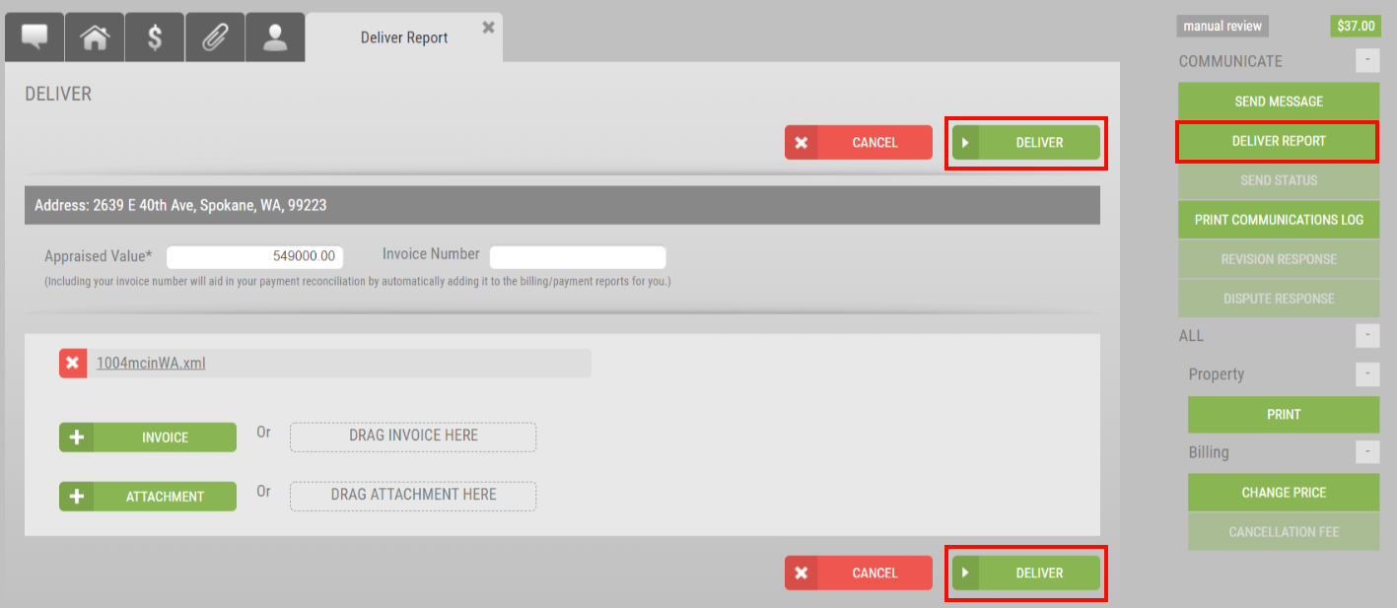
Both Deliver buttons perform the exact same delivery action. You will know the report has been delivered successfully when you are directed back to the Communications Log.
Please contact (Your Contact Information Here) for additional questions.

