(Your Company Name Here) Release Scheduled for
Friday Morning, January 21st, 2022
Release Information for Lenders

Starting Friday morning, January 21st, 2022, a new version of (Your Company Name Here) will be available for you. Since our last release, our team has been busy over the holiday season preparing for this substantial system update. This release introduces nearly a dozen new features! VA COE Auto Re-Pull, Estimated Closing Date available on Residential orders, and new division settings are just a few updates. Read on for a complete description of each enhancement we are introducing.

Bulletin Contents
- VA COE Auto Re-Pull | - Messaging Posted to VA Portal
- Bypass Billing Restrictions | - Resend All Pending Invites
- Export All Pending Invites | - Estimate Closing Date Field
- Require Investor on New Orders | - Reinspection Vacation Notice
- Updated Review Bids Screen | - Require Commercial Fields

Automatic Re-Pull of VA Certificate of Eligibility
Since we introduced the (Your Company Name Here)-VA Portal connection, we have been implementing additional automated processes to streamline the overall VA order practice. Now, if (Your Company Name Here) is unable to verify an active Certificate of Eligibility (COE), we will immediately attempt to auto-pull a valid COE for the Primary Obligor. Should the second COE check be unsuccessful, we will import the full, comprehensive issue log directly from the VA Portal, post it to the Communications Log and shall send out email notifications to the users on the order. Please note that if (Your Company Name Here) is unable to verify the COE, you will need to request the COE manually through the VA Portal, per VA guidelines.
How To Use This Feature:
The COE verification process is entirely checked in the background and does not require you to place your VA orders differently. If the COE cannot be verified on the second attempt, users on the VA order will receive an updated email notification specifying what errors the VA returned. The following is an example of a possible error you may receive.
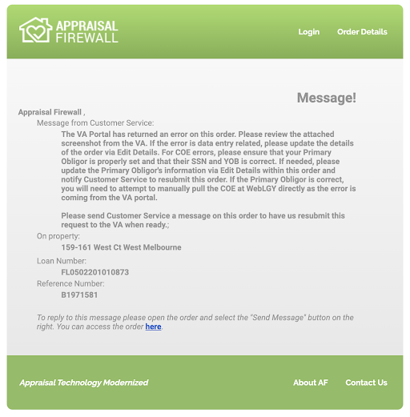
This same error will automatically be posted on the Communications Log, along with a screenshot directly imported from the VA Portal.

Messages to VA Appraisers Posted to VA Portal
With this release, we are thrilled to announce a new time saving feature: any messages (including attachments) you send to the VA appraiser within (Your Company Name Here) will be automatically posted to the VA Portal! This process eliminates the necessity to login to the VA Portal directly to enter your message within the Notes section. Additionally, messages sent through (Your Company Name Here) will continue to be documented on the Communications Log.

How To Use This Feature:
Within a VA appraisal order, select the Send Message feature and choose Appraiser from the recipient dropdown. Compose your message and attachments (if any). Select the Send Message button below the message field. The message will be posted on the Communications Log and imported to the Notes section within the VA Portal.

Save Time by Bypassing Billing Restrictions for Admins
Administrators can enable a brand-new user setting within a fellow Administrator user’s profile to Bypass Billing Restrictions. This new setting will allow those Administrator users access to all payment type options so the order can be placed immediately, without any intervention by Customer Service. Bypassing this restriction is especially helpful when the Require Credit Card, Bank Account, and eCheck Payment division setting is enabled. Please note, this feature will only be available to Administrator user types and not for other managed users.

How To Use This Feature:
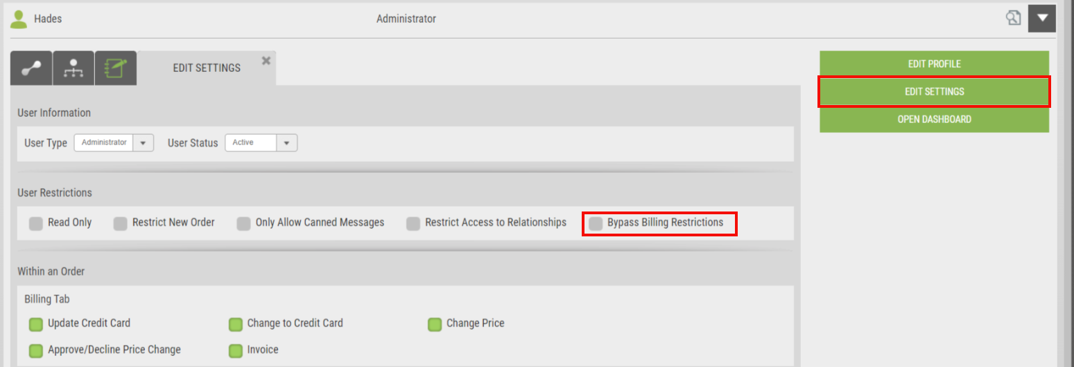
Login to your Administrator account and select Relationships. From the tabs across the top of the screen, choose Users. Expand an Administrator from your user list and choose Edit Settings from the right.

Enable the Bypass Billing Restrictions setting under User Restrictions. Scroll to the bottom of Edit Settings and click SAVE to retain your changes.
When the user that has the billing restrictions bypassed places a new order, all billing options will be reflected under Payment Method section.
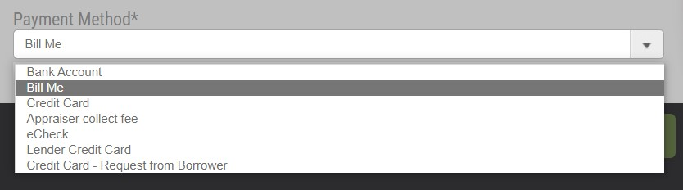
Managed users will continue to be restricted to the Require Credit Card, Bank Account, or eCheck Payment setting. Additionally, since the Bypass Billing Restrictions setting applies to a specific user, the restriction will apply to all divisions the user in question is associated.

Resend Your Entire Appraiser Pending Invitation List
Appraiser panel management is an on-going process to ensure your business volume can be met. For expediency, we are introducing a Resend All feature within the Pending Invites section that will resend all pending appraiser invitations at once, as opposed to selecting Resend on every individual outstanding invitation.

How To Use This Feature:
From Relationships, choose the appropriate division, and select Manage Appraisers. Click the Invite Appraiser button to the right of the map. Under the Pending Invites section, there is a new Resend All link available.
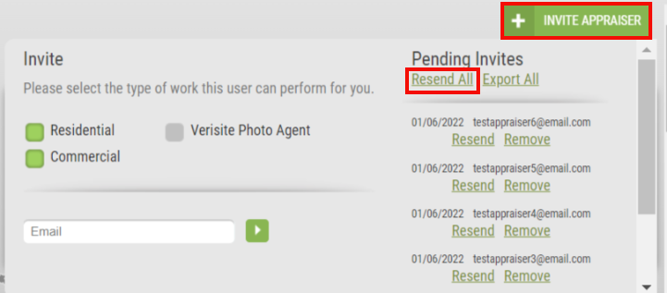
Selecting Resend All will trigger another invitation email to the entire list of outstanding invitations.

Export Your Invited Appraisers List
As a companion piece to our updated Invite Appraiser window, we have added an Export All feature to partner with the new Resend All pending invites. The Export All function will generate a spreadsheet of all the appraiser invitations that are still outstanding so you can view which appraisers need a follow up, if necessary.

How To Use This Feature:
From Relationships, choose the division that you want to work in, and select Manage Appraisers. Click the Invite Appraiser button to the right of the map. Under the Pending Invites section, there is a new Export All link available.
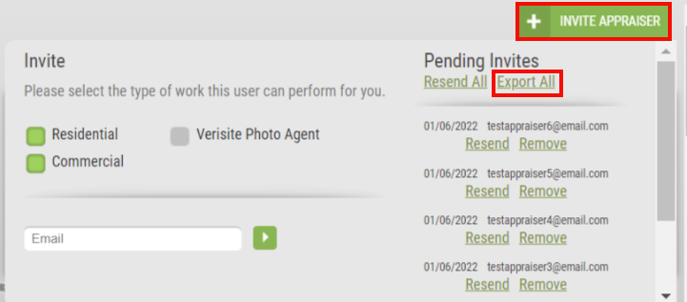
Choosing Export All will download a .CSV file which will display the email address and the date the invitation was sent. Please note that at least one pending invitation must be available to generate the report successfully. Appraisers that have successfully created an account will not be displayed in the report as they will no longer be in an invited status.

Estimated Closing Date Added to Residential Orders
Information at-a-glance is key when the processing team needs to view the status of an appraisal order in relation to when the loan is expected to close. We have added the Estimated Closing Date field to Residential orders so users can have access to this data directly on their customized dashboard, property information, and custom reporting. Adhering to compliancy, the Estimated Closing Date will not be visible or accessible to appraisers.

How To Use This Feature:
On the New Order screen, Estimated Closing Date is a field that can be found within the Loan section. Clicking in the Estimated Closing Date field will display a calendar, where users can select the appropriate date.
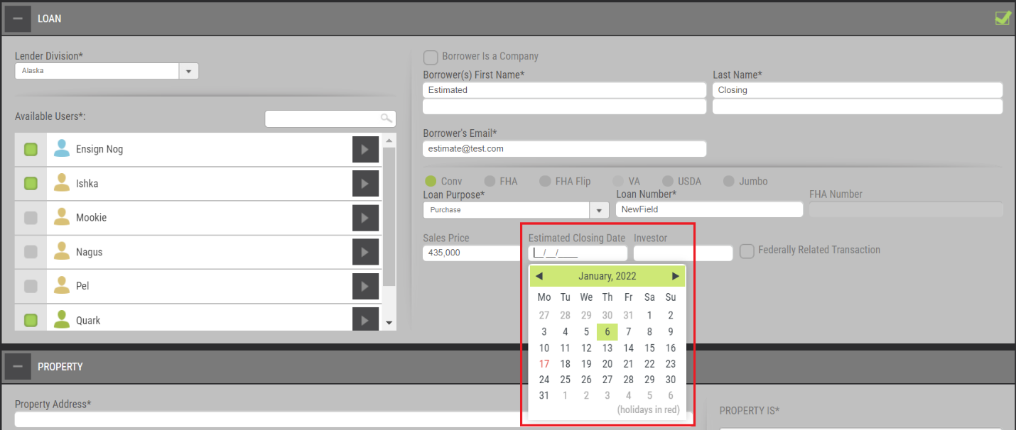
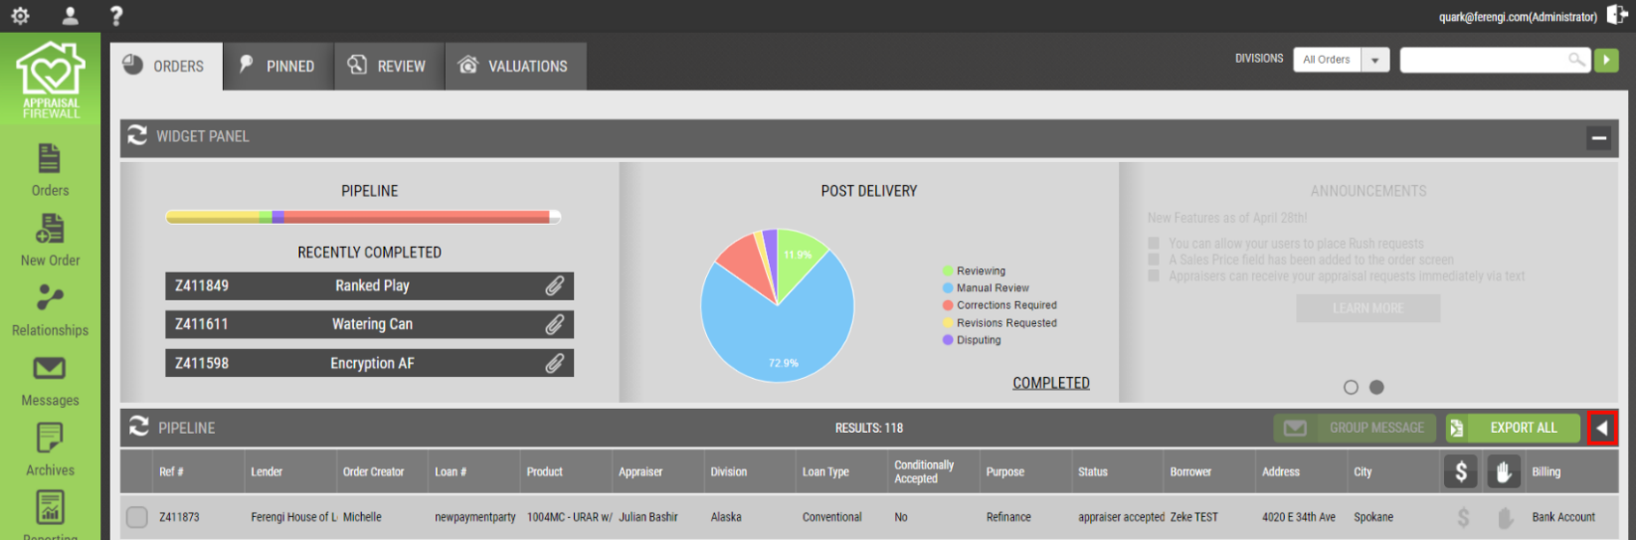
Complete the rest of the new order as usual. To display the Estimated Closing Date on the dashboard, select the column customizer tool.

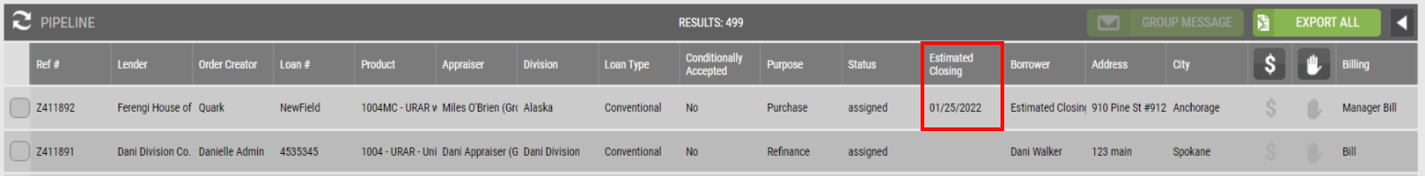
From the Available Fields list, pull Estimated Closing over to the Current Fields list, where users can customize how they want their columns displayed on their dashboard. Please note that an Estimated Closing must be entered to be reflected on the dashboard.
Within the order’s Property Information, the Estimated Closing can be found under the Appraisal Type section, within Edit Details, and on the Print view form.
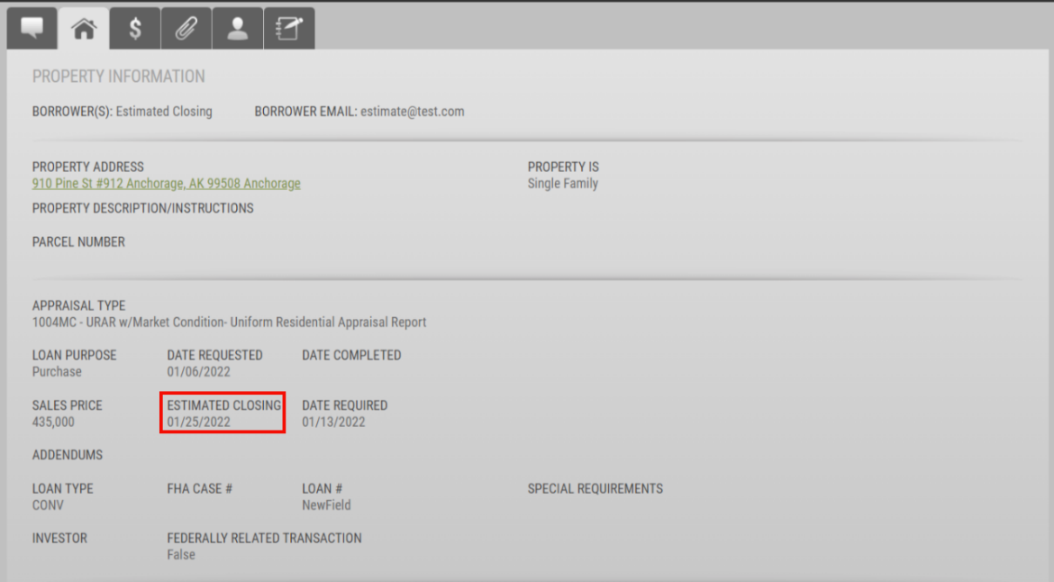

For reporting purposes, Estimated Closing is available from the dashboard Export All feature. If users have added this field through the column customizer, Estimated Closing will already be enabled from the Export All overlay.
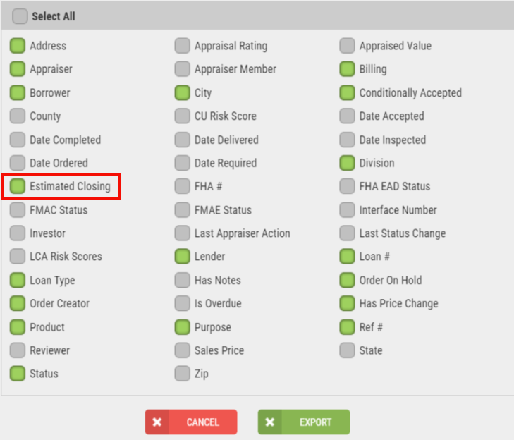
We have also added the Estimated Closing Date field as an available option for custom reports, which can be found under the Order Fields section.
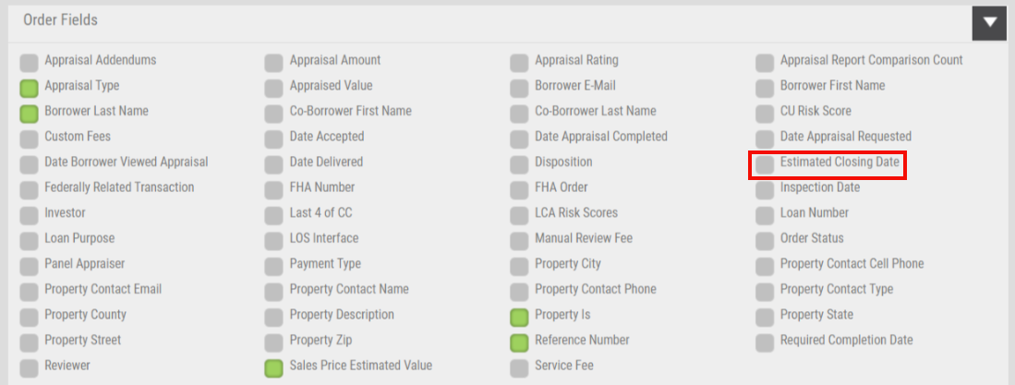
The dates returned on the Export All or custom reporting will match the Estimated Closing as entered on the order.

Division Setting to Require Investor on New Orders
In our November 2021 release, we added the Investor field to new orders, property details, the dashboard customization tool, and reporting. Now, we are extending this field as a division setting, where you can enable the Investor field as a requirement on all new residential orders. This feature will ensure that users must enter the Investor upon order placement.

How To Use This Feature:
From Relationships, select and expand the division you want to implement this setting and choose Edit Settings. Expand the General settings portion. Under the Placing Orders segment, Require Investor will be available for you to enable.
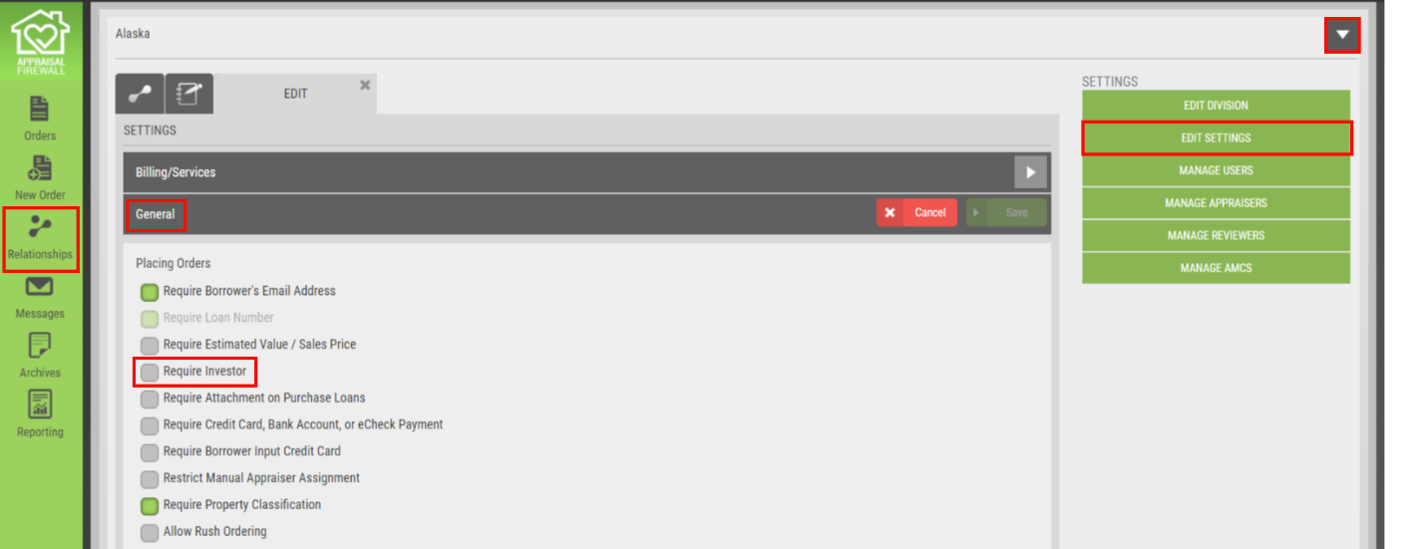
Once you enable Require Investor, be sure to select the SAVE button to retain your changes.
On the New Order screen, the Investor field will now reflect an asterisk, marking the field as a requirement in the Loan section. Complete the rest of the order as normal.
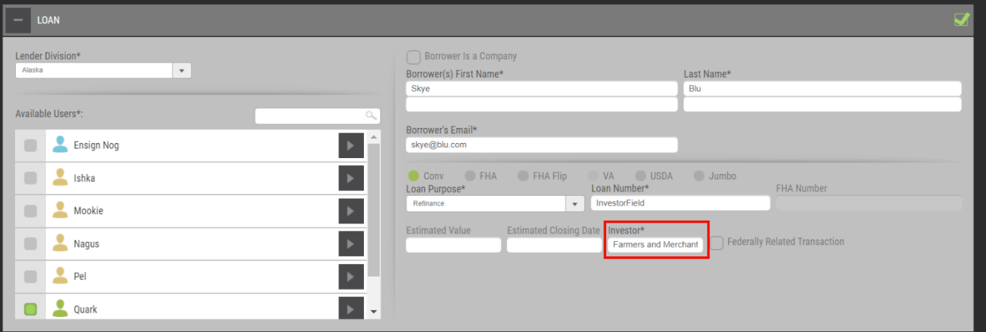
All the features from our November 2021 release will remain intact. The Investor field will still be a customizable option on your dashboard, reflected on the property details screen, visible on the print view, and available in the Order Fields section of custom reporting.

Order Reinspections Displays Appraiser on Vacation
To facilitate a simplified order process, we have added a new feature on the Order Reinspection placement that will disclose if the appraiser has enabled their vacation dates setting. Since the Order Reinspection routes the order to the appraiser that completed the initial appraisal order, reinspections can remain in that appraiser’s queue until they have returned from their specified vacation end date. This often results in reinspections being completed in a timeframe later than expected. With this Communication Log message, Administrators can take immediate action to assign the order to another appraiser, or adjust the date required to accommodate when the appraiser will be back from vacation.

How To Use This Feature:
Select the Order Reinspection option from an existing order and complete the placement process as usual. Upon placement, a notification will be posted to the Communications Log stating that the appraiser is on vacation and when the appraiser is expected back.
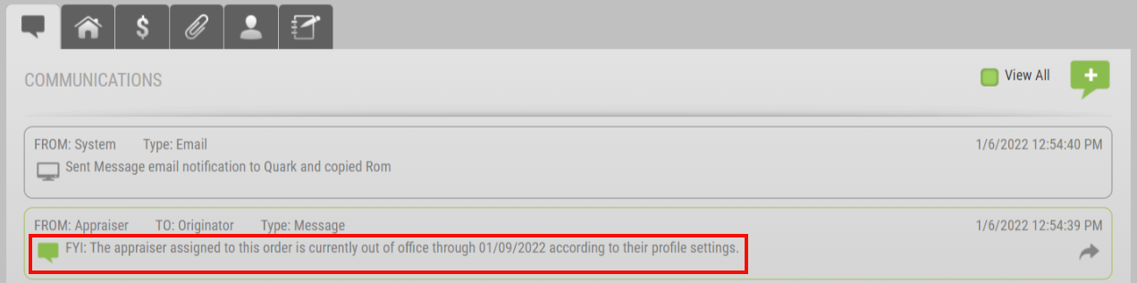
Email notifications will also be sent to the order originators with this same information. Please note that the vacation notification is contingent on the appraiser enabling this setting withing their Profile. Should the appraiser not utilize the vacation date feature, the reinspection order will route the order to the appraiser without the notification.

Appraiser Name Shown on Review Bids Screen
To assist in providing all the information you need at the forefront of the Residential and Commercial bidding Review Bids screen, we are replacing Appraiser1, Appraiser2, etc. with the Appraiser’s name. Now, you do not need to expand every review bid line item to see which appraiser provided which fee and turn time! As a bonus feature, we are bringing the number of messages sent between you and the appraiser to the appraiser header bar. This enhancement will not only be available for Commercial orders, but we are also bringing this to Residential bidding orders. Please note, that any appraiser information will remain hidden from managed users, even if they have access to review bids.

How To Use This Feature:
Place your Commercial and Residential bidding orders as usual. Within the order, select the Review Bids button along the right. You will now see the appraiser’s name listed in the header bar. The name displayed is pulled directly from the contact name listed in the appraiser’s profile.
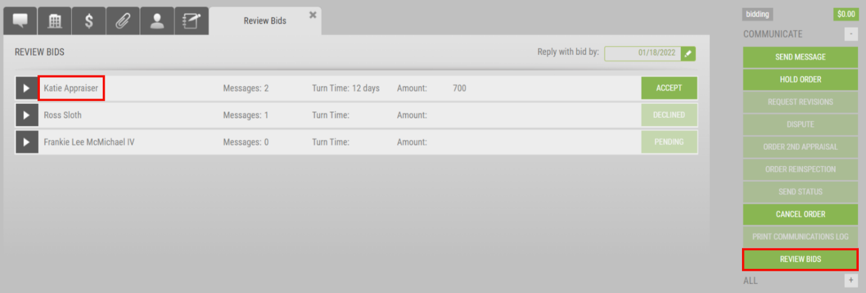

Require Additional Commercial Appraisal Fields
Commercial appraisal reports contain a vast amount of information. Several additional key data fields for Commercial orders can be added to the Property Information tab with this release. Administrators can now enable a Commercial division setting requiring commercial appraisers to enter fields such as the Appraisal Effective Date, Insurable Value, and more on delivery. Having a snapshot of basic commercial appraisal data points in the property details screen grants you quick access without the necessity to sift through the appraisal report to verify a simple field.

How To Use This Feature:
From Relationships, expand a division that is set up to place Commercial orders, select Edit Settings, and expand the Commercial section. Located under Require Borrower’s Email Address you will see this new setting, Require Appraisal Fields from Appraiser.
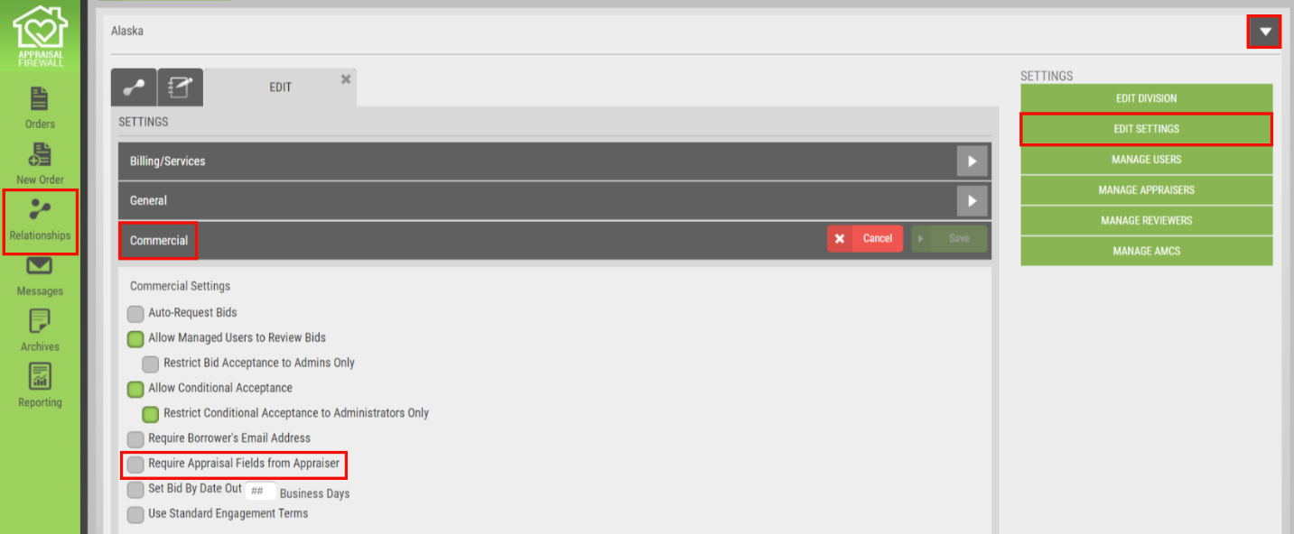
Enable the box to the left of the setting and select the SAVE button to retain your changes. This will require commercial appraisers to supply the following fields during the delivery process on Commercial appraisal orders. Required fields will be marked by an asterisk.
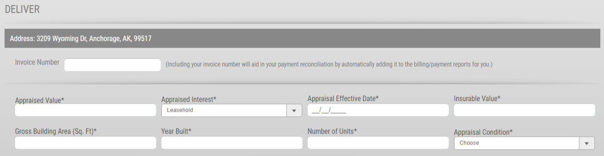
The appraiser will be unable to deliver the commercial report successfully without providing information to these fields. Upon delivery, we have added a new section titled Deliver Report at the bottom of the Property Information screen where these fields can be viewed. Please note the Print Order form will not receive these updates as the Print form is a snapshot of the order details and requirements, and not a review of completed appraisal report fields.
For questions or concerns, please contact (Your Contact Information Here).

