(Your Company Name Here) Release Scheduled for
Friday Morning, January 21st, 2022
Release Information for Appraisers

Starting Friday morning, January 21st, 2022, a new version of (Your Company Name Here) will be available for you. Since our last release, our team has been busy over the holiday season preparing for this system update. This release introduces an updated Commercial order delivery screen. Read on for a complete description.

Additional Commercial Order Fields on Delivery
Commercial appraisal reports contain a vast amount of information. Several additional key data fields for Commercial orders can be added to the Property Information tab with this release. Lenders can now enable a setting requiring additional fields to be submitted upon delivery, specifically for Commercial orders. If the lender has enabled this new requirement, you will see an updated delivery screen where the fields will be designated with an asterisk.
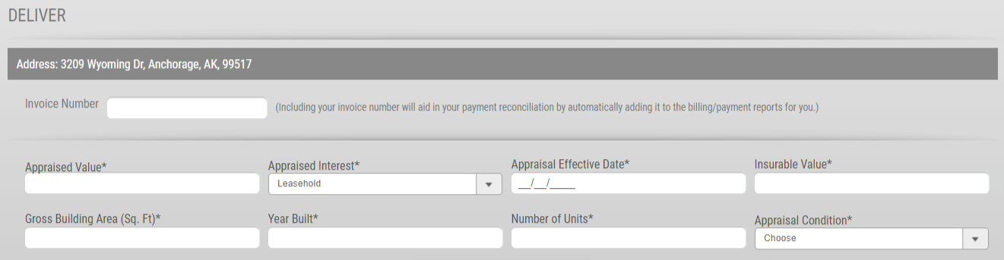
How To Use This Feature:
This feature is only applicable to Commercial orders. When you are ready to deliver your commercial appraisal report, select the Deliver Report button along the right.
These newly added fields can be located under the Invoice Number section. Enter the required information to the appropriate field. Uploading the report remains unchanged. Please note that if you do not see an asterisk adjacent to each new field, you will not be required to enter this information during the Commercial order delivery process. Upon delivery, we have added a new section titled Deliver Report at the bottom of the Property Information screen where these fields can be viewed. As an aside, the Print Order form will not receive these updates as the Print form is a snapshot of the order details and requirements, and not a review of completed appraisal report fields.

For any questions or concerns, please contact (Your Contact Information Here).

