**(Your Company Name Here) Enhancements Scheduled for  
Friday Morning, November 19th, 2021**

**Release Information for Lender Administrators**

**Starting Friday morning, November 19th, 2021,**a new version of (Your Company Name Here) will be available for you. This release displays **payment remittance responsibilities** on the Billing Details tab, **Investor field** available on the dashboard, a new **Appraiser Groups management report**, **relaxed restrictions on Canned Messaging** for internal communication, and an optional division setting to **require the Estimated Value or Sales Price** on a new order. Through this release, we have added more customization to assist in streamlining the appraisal process so your appraisal desk teams can track and manage their orders easier than ever before!

# **Remit Payment to Appraiser Party Displayed in Billing Tab**

Confusion can occur regarding who the party responsible for remitting payment to the appraiser should be. This often results in multiple inquiries by appraisers to track down who is responsible for sending payment. We have added the party responsible for paying the appraiser directly on the Billing Details tab to significantly decrease payment inquiries for all parties involved. Additionally, we have included a second line-item notating if the appraiser is responsible for paying any accumulated service/billing fees. With these enhancements, appraisers and lenders alike will quickly be able to deduce where payment will be coming from and how fees are assessed.

# **How To Use This Feature:**

Open any order and select the **Billing Details** tab ($ icon). Located near the bottom of the screen is where the party responsible for payment will be listed. Should the appraiser be responsible for paying any service/billing fees, this will be listed directly under the party payment remittance line. *Please note only service/billing fees the appraiser is responsible for paying will be listed.*

# **Investor Field Added to Dashboard Options**

Customizing the dashboard is a great way to configure the information you want to see without having to navigate through multiple screens. We have added **Investor** as an available field within the column chooser customization tool, bypassing the need to access the property information to view the name of the Investor. When Investor is added to your dashboard, you will see **Investor** as the column header, where the Investor name will be visible. By including Investor to the dashboard, we have also included Investor as a field within the **Export All** feature.

# **How To Use This Feature:**

From the dashboard view, select the arrow on the right.

An overlay will appear listing all available fields and all current fields. **Investor** will be listed under **Available Fields**.

To add Investor to the dashboard, drag Investor from the Available Fields list to the Current Fields list, and select **Commit**. Investor will be added as a column on the dashboard. Through the addition of adding Investor as an available dashboard option, Investor has also been added to the **Export All** feature. Select the **Export All** button on your dashboard.

An overlay will display a variety of options to generate on the report. Any items that are currently on your dashboard will automatically be enabled. If Investor is not currently on your dashboard, you can enable Investor for the purpose of the report while not adding Investor as an available column on your dashboard.

Select **Export** to generate the report.

# **New Appraiser Group Management Report**

To make sure your appraiser groups are as up to date as possible, we have added the **Appraiser Group** report as an available canned report option. This new report will list those members that have been added to existing appraiser groups on your active lender panels. Such additions made during the selected timeframe allow you to make the necessary adjustments to your panels, ensuring you have an up-to-date roster.

# **How To Use This Feature:**

Select the **Reporting** option from the main dashboard. Towards the bottom of the Standard Reports section is the newly added **Appraiser Groups** report. Expand the report to set a date range, send the report via email, or setup this report to run automatically.

By default, the date range will reflect the last 30 days. Once the desired date range is in place, select **Run Report**. A .CSV file will be generated for your review. The report will display any members that have been added to an existing appraiser group on your panel(s) in the specified timeframe. Within the contents of the report are the group administrator’s name, name of the recently added appraiser member, date the member was created, and the division(s) the member is associated.

# **Internal Messaging Permitted with Canned Messaging Restrictions**

Approximately a year ago, (Your Company Name Here) introduced Canned Messages to limit what kind of messages could be passed between processors and appraisers. This assisted in quicker responses to inquiries while remaining in a fully compliant and contained environment. When Canned Messaging restrictions are in place, you can now communicate internally with your team without the need to go outside of the system. The message field is open to enter an individually composed message to Originators, Administrators, and/or Customer Service so you can quickly respond to inquiries as needed, keeping all communication confined within the order. Any messages directed to the appraiser will continue to result in communicating with existing canned messages.

# **How To Use This Feature:**

Users that have the ***Only Allow Canned Messages*** restriction in place can open any order from their dashboard. Select the **Send Message** option to the right. Users with the messaging restriction will see that when they switch the recipient dropdown menu to any user outside of the Appraiser option, that the message field will allow the user to enter a custom message.

Selecting Administrators, Originators, or Customer Service will change the messaging field from a light gray color to white, indicating that a custom message can be composed and sent to the intended recipient.

Once the message is sent, the custom created message will be posted on the Communication Log as with any other messaging type.

# **Require Estimated Value/Sales Price Division Setting**

To help with faster appraiser acceptance and more timely delivered reports, we are pleased to include **Require Estimated Value/Sales Price** as an optional divisional setting. Once this setting is enabled, processors will be required to enter the **Sales Price on Purchases** or **Estimated Value on Refinances** to have the new order placed successfully.

# **How To Use This Feature:**

From the **Relationships** menu option, select the division you want to enable this setting. Expand the division, choose **Edit Settings**, and expand the **General** section.

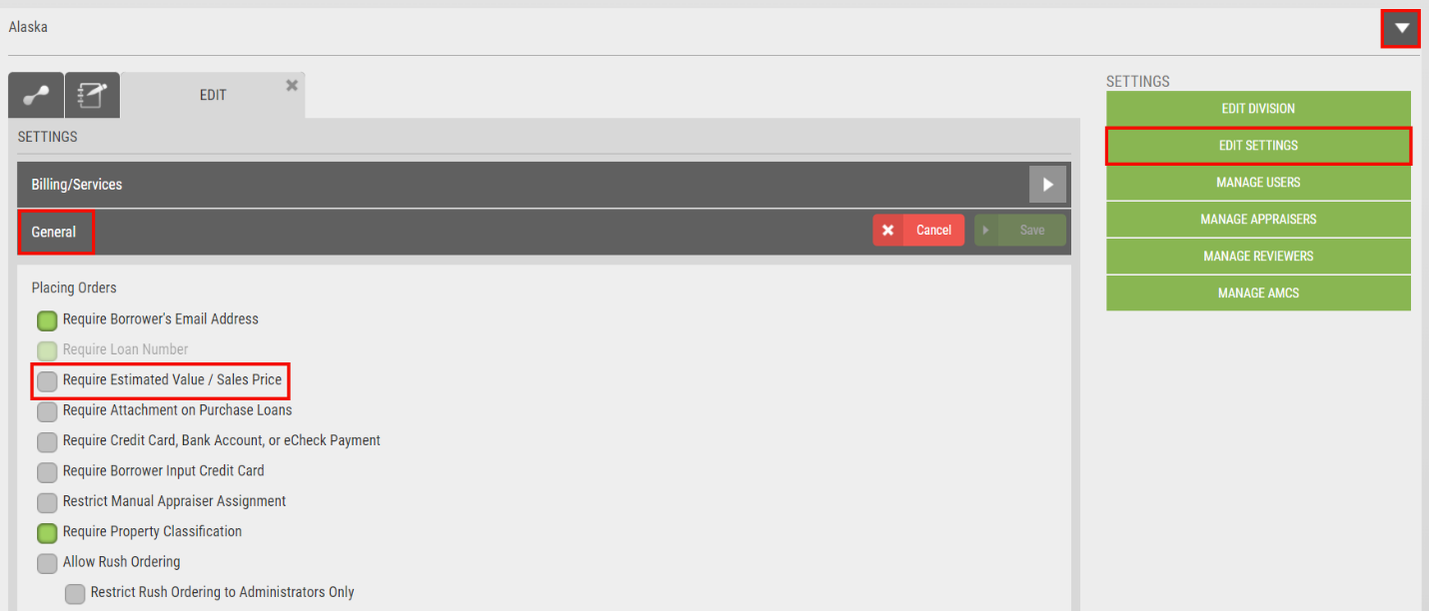

Enable the **Require Estimated Value/Sales Price** checkbox if you would like this setting required on order placement. Once the setting is enabled, be sure to select the **SAVE** button.

From the **New Order** screen, choose **Residential**, as this setting is only applicable to Residential order types. Select the appropriate division. Within the Loan section, there will be an asterisk adjacent to the Estimated Value field for Refinance or an asterisk adjacent to the Sales Price for Purchase. ***Please note the asterisk designates the field is required.***

Once the order has been placed successfully, the Estimated Value or Sales Price will be reflected on the Property Information tab, including the print view option. ***Please note the Estimated Value will be hidden on the appraiser view, but visible for managed users.***

For any questions, please contact us at (Your Contact Information Here).